GOAL  What is it exactly that YOU really want? Not what you think you should want, or others want, or what you want for others.  What is the reason that you want this?  When will you achieve it by?  How will you know when you have achieved it? What will you have? Who will you be? What will you be doing?  What would you like as an outcome for completing this activity - such as the first action/set of action/strategy/solution?  What are the benefits for you in achieving your goal?  Who else will benefit from you achieving your goal?  When you have achieved your goal what does it look like?  What will you be able to do that you cannot do now?  What do you no longer have?  Imagine a time in the future where all obstacles are removed, and you have achieved your goal:  What will you be saying to yourself?  What will other people be saying to you?  What will you have that you do not have now?  How do you feel?  What do you see?  What do you hear?  What is different? | 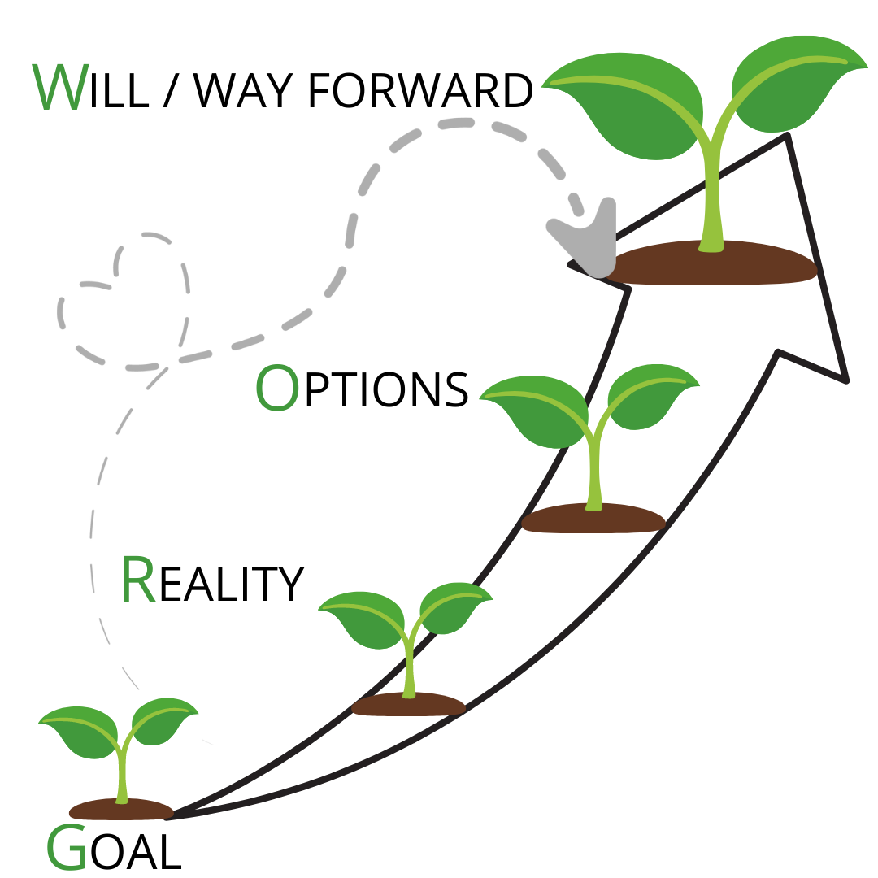 | OPTIONS  What options do you have to achieve your goal?  What else could you do? What else?  What advice would you give to someone else that you cared about with the same goal?  If there were anything else, what would it be?  If you had no limitations on what you could do, what would you do?  What has worked in the past?  What steps could you take?  Who do you know that who already achieved this?  Who could help you with this?  Where could you find out more information?  What are the advantages and disadvantages of each option?  Which options will you choose to act upon?  Which option do you feel would bring you the highest rewards that you are committed to taking right now?  Do you need to break down this option into smaller steps? If so, what are they? How will you know you have achieved each step?
REALITY  What is your current reality? What is happening right now around this goal? What is the current situation?  On a scale of 1–10, where your desired reality is 10, what number are you at right now?  What number would you like to be at?  How do you feel about this?  What impact is this having on you?  What are you tolerating that you would rather not?  What is the gap between your desired outcome and your current reality?  How does this impact other areas of your life?  What have you done, or what are you currently doing that takes you nearer to achieving your goal?  What is getting in the way of you achieving your goal right now?  What is it that you are doing that is getting in the way?  What is it that you are not doing that is getting in the way?  What is the real issue? |  | WAY FORWARD  What are the first 3 actions that you could start straight away?  When will you achieve them by?  What could anyone else do to give you support and when will you ask for it?  How committed are you, on a scale of 1–10, to taking this action?  If it is not a 10, what would make it a 10?  What will you commit to doing?  What is the cost of not doing this?  Is there anything you need to put in place before you start?  What obstacles do you foresee may potentially get in your way?  If you encounter these, how will you deal with them to ensure you successfully achieve your goal?  How will you know when you have achieved your goal?  How will you celebrate your success?

GOAL

What is it exactly that YOU really want? Not what you think you should want, or others want, or what you want for others.
What is the reason that you want this?

When will you achieve it by?
How will you know when you have achieved it?
What will you have?
Who will you be?
What will you be doing?

What would you like as an outcome for completing this activity - such as the first action/set of action/strategy/solution?

What are the benefits for you in achieving your goal?

Who else will benefit from you achieving your goal?

When you have achieved your goal what does it look like?

What will you be able to do that you cannot do now?

What do you no longer have?

Imagine a time in the future where all obstacles are removed, and you have achieved your goal:
What will you be saying to yourself? What will other people be saying to you?
What will you have that you do not have now?
How do you feel? What do you see? What do you hear?
What is different?

REALITY

What is your current reality? What is happening right now around this goal? What is the current situation?

On a scale of 1–10, where your desired reality is 10, what number are you at right now?
What number would you like to be at?
How do you feel about this?

What impact is this having on you?

What are you tolerating that you would rather not?

What is the gap between your desired outcome and your current reality?

How does this impact other areas of your life?

What have you done, or what are you currently doing that takes you nearer to achieving your goal?

What are you doing that is getting in the way of your goal?
What is it that you are doing that is getting in the way?
What is it that you are not doing that is getting in the way?

What is the real issue?

OPTIONS

What options do you have to achieve your goal?

What else could you do? What else?

What advice would you give to someone else that you cared about with the same goal?

If there were anything else, what would it be?

If you had no limitations on what you could do, what would you do?

What has worked in the past?

What steps could you take?

Who do you know who has already achieved this?

Who could help you with this?

Where could you find out more information?

What are the advantages and disadvantages of each option?

Which options will you choose to act upon?

Which option do you feel would bring you the highest rewards that you are committed to taking right now?

Do you need to break down this option into smaller steps? If so, what are they? How will you know you have achieved each step?

WILL / WAY FORWARD

What are the first 3 actions that you could start straight away?

When will you achieve them by?

What could anyone else do to give you support and when will you ask for it?

How committed are you, on a scale of 1–10, to taking this action?

If it is not a 10, what would make it a 10?

What will you commit to doing?

What is the cost of not doing this?

Is there anything you need to put in place before you start?

What obstacles do you foresee may potentially get in your way?

If you encounter these, how will you deal with them to ensure you successfully achieve your goal?

How will you know when you have achieved your goal?

How will you celebrate your success?

